**Nile university**

**Project Title**

**"COVID-19 in Africa: Examining the Impact and Prevalence of the Disease"**

**COVID-19**

**By**

Shrouk Hesham 19106271

Submitted in partial fulfillment of the requirements

For MATH201 project

**COVID-19**

**Date**

2\1\2021

**Abstract**

A widespread virus that threatens the world appeared in late 2019 in Wuhan Hubei Province in China originated through bats where one person took a bat containing the virus and spread the virus quickly through inhalation or contact with the infected and its symptoms are usually Thursday, cough, sore throat, shortness of breath and loss of taste and smell. It affects all ages but is dangerous for the elderly and those with chronic diseases. The treatment is usually vitamins to strengthen the body because the anti-retroviral agents have not yet been discovered and on suspected cases of isolation in the home and prevent communication with anyone to prevent there are strict measures in hospitals and public places Governments have decided to ban all cities to reduce the spread of the virus, stop flying and the world has been paralyzed in all its functions we presented COVID-19 we appear the flow of COVID-19 by making a overview and appear the strategies with taking into thought the S-I-R Show. In expansion, utilizing MATLAB, and arachnoid to fathom the differential conditions of the widespread and make a visualization of the influenced ages, framework elements in nonappearance of any preventive measures, impact of working out social removing in expansion to the existing shutdowns, and the impact of lifting closures and unwinding social removing after 100 days. In expansion, we given profitable instinct with respect to the anticipated direction of the malady in Africa.COVID-19 in Africa We gotten a dataset of the worldwide COVID-19 cases. We extricated data on COVID-19 cases in African nations and make a visualization for Africa. Our comes about appear that the scale of the widespread is moo over numerous nations in Africa.

**Table of contents**

Chapter page

ABSTRACT 2

TABLE OF CONTENTS 3

LIST OF TABLES iv

LIST OF FIGURES v

Section I: Introduction 4

SECTION II: Background and Literature Review 7

Section header 7

Sub heading (heading 2) 8

Figures 11

Tables 12

Equations 13

SECTION III: METHODOLOGY 14

Code description ………………………………………………………………19

Flowchart………………………………………………………………………20

SECTION IV: RESULTS 21

SECTION IIV: DISCUSSION…………………………………………………………………. 29

SECTION V: CONCLUSION 30

REFERENCES 31

**Section 1: introduction**

In late December 2019, an unknown virus spread in Wuhan, Hubei Province, China, infected 9,720 people in China, 213 deaths and 106 deaths in 19 countries as of January 31, 2020.

A few days later, the virus was identified as coronavirus, and its symptoms are:

**.** Fever,

**.** Cough,

**.** Shortness of breath .The symptoms may appear from 2−14 days (incubation period) after contact with an infected person and may range from mild to severe illness The duration of quarantine is usually for the incubation period of the disease, that is, the time from contact with the infection to developing the sickness. For COVID-19, the period of quarantine is 14 days. Someone who has been released from COVID-19 quarantine is not considered at risk for spreading the virus to others.

America's most populous recorded 19,212,044 hits and 338,283 deaths. It is the most affected country. The number of injuries in the world 80,310,189 injuries, the number of deaths1,759,740 deaths and the number of recovered 56,604,103.

Since there are many countries and scientists tried throughout the year to make vaccines for this virus, but the attempts were unsuccessful and there are many current countries that discovered initial vaccines for corona such as China, Australia and America and began to spread vaccines in the countries of the world some of them succeeded and some failed.

Corona had a lot of effects on the world other than death for the infected, but there were effects in the economy in a big way and all the countries were affected by corona severely affected as the exciting industries stopped due to the virus and the countries could not get rid of this effect before the second wave came in winter 2020 in the late months of the year and the return of the virus severely increased the number of infected and deaths more and the level of the first wave and this will lead to serious damage to the economy Again in the world.

Many African countries have campaigned against the spread of coronavirus despite their little reputation in health systems Africa is one of the largest continents in the world, but nevertheless it has recorded the lowest number of casualties and death preparation, which is much lower than the rest of the world, with Africa recording

Where the first case of coronal disease was found appeared on the continent of Africa in Egypt on February 14, there were fears that the virus will spread very 37,000 cases and 230,000 deaths in Europe, 580,000 in the Americas, 205,000 in Asia, and the disease is less widespread among Africans quickly and defeat the health system on the continent and most governments in Africa united to make tough decisions to slow the spread of the virus and quick solutions were provided so as not to become like other continents. One of the reasons why Africa has been less infected than other continents is screening at different airports on the continent and isolation in treatment, and it's a hot continent.

The consultants say that the existing strategy could allow African countries to reduce closures because it causes a huge hardship for those who depend on the day they can spend on their families and families, yet there is an increased risk of famine in many African countries Where he damaged the Mediterranean average and threatened to increase poverty rates.

: In 2020, 2.7 million Africans had killed more than 65,000 people and increased the last quarter more. From the whole year in addition to the emergence of a number of infectious mutations and 28 of the 54 countries reported an increase in the number of cases since the beginning of October and resulted in the result that about 22 thousand new needs are reported per day and most of the cases recorded still appear in South Africa and Morocco because they have the ability to do the tests.

New mutations detected in the virus that make it more transferable increase the likelihood that the second wave can become more dangerous than the initial wave even in countries with stronger health systems and which have not experienced sharp spikes yet during the second wave is still at risk after the spread of the virus in rural areas.

The British government must do everything in its power to keep the strain discovered in South Africa away from the UK, otherwise it could be a "major game changer" in its handling of the pandemic.

"The strain detected in South Africa worries experts, because the vaccine may not react in the same way, or not work in exactly the same way," the transport minister said.

"If this proves to be a reality, allowing her to reach the country would be a tragedy... We have to do everything we can to prevent this from happening."

The world's leading producers of vaccines against are quick to see if their vaccines are effective in the face of new mutations in South Africa and Br

**SECTION 2: Background and Literature Review**

Coronavirus is one of the most dangerous and fastest diseases spread in the current century, where it began at the end of 2019 and led to the death of many people around the world and is a immune virus that infects the lung and settles in survival, which leads to shortness of breath and is in stages and the students of medical universities were studying this virus before its onset, but nevertheless did not discover a cure or serum to limit its spread and symptoms of this disease and high degree of Heat, shortness of breath, etc., medical scientists tried to make throughout the year a vaccine for this virus, but the virus was changing its shape and becoming more dangerous and when it came in its new form at the end of 2020 and became the fastest widespread and severe and is considered corona one of the most dangerous diseases suffered by the world today and for more than a year and scientists do not know at any time can end or decay but scientists from China and Australia And America has released many vaccines that have the potential to eliminate the virus Mortal coronavirus continues to spread across the globe, and mathematical models can be used to show suspected, recovered, and deceased coronavirus patients, as well as the number of people, tested. Researchers still don't know whether surviving an infection with COVID-19 means that you have long-lasting immunity and, if so, for how long? In order to understand this, We believe that this study may lead to a better estimate of the spread of this pandemic in the future.

In this research we talked about the beginning of the corona virus. Covid-19 appeared in Wuhan Hubei Province in China originated through bats where one person ate a bat containing the virus and spread the virus quickly through inhalation or contact with the infected. The world health organization (WHO) has a plan to investigate the origins of the covid-19 virus. The investigation has started in Wuhan trying to trace the virus's path to know the whole story and preventing future disaster. The known symptoms of the virus are fever, shortness of breath and loss of sense of smell and taste. When symptoms appear, the infected person should keep himself from dealing with anyone from 2-14 days to make sure he recovers because the virus is transmitted quickly. Covid-19 had a big impact on the world, life was stopped because of it and the world was suddenly paralyzed. t was expected to affect Africa very much because of its poor health system, but Africa was one of the least continents in the number of injuries and death some think it is due to the heat of its weather or the genes of its people, but like the rest of the world affects the economy in Africa a lot because most African countries threaten to enter into famines because of the economy and low income. Covid-19 has been investigated before so they can find how much the virus effect in it.

There are a lot of things related to my research and the research of others because the coronavirus is one of the most recent things in our time because it controls the country's economy and education and all things and hinders the progress of the country and many things in the circulation of news about the corona pandemic everyone is trying to expose all the ideas and news about this subject and share people information to have enough information about the virus and awareness enough and how to deal with it and where A lot of research shares the statistics and equations found in our research and these researches help us understand the results and statistics and we have enough news and are aware of everything that is happening due to the corona pandemic in the world.

The key concepts of this research (covid-19) could be different from person to other. People defined Covid-19 as an infectious disease caused by the last detected virus from the coronavirus strain. There was no knowledge of the new virus and its disease before it began to spread in the Chinese city of Wuhan in December 2019. Coved-19 has now become a pandemic affecting many countries around the world. Quarantine means separating a group of people from others and restricting the movement of people who have been or may have been exposed to the disease so that they can be monitored for the disease. Self-isolation defined when a person with fever, cough or other symptoms of Coved-19 disease needs his or her home and refrains from going to work, school or public places. Such isolation can occur voluntarily or on the basis of a recommendation from a health-care provider. People identify infected people by observing the most common symptoms of Coved-19 are fever, fatigue and dry cough. Other less common but potentially common symptoms include pain and aches, nasal congestion, headaches, conjunctivitis, sore throat, diarrhea, loss of sense of taste or smell, rash or discoloration of fingers or toes. These symptoms are usually mild and begin gradually. Some people become infected with very mild symptoms. Most people (about 80 percent) are recovering of the disease without the need for special treatment. However, almost one in five people with Covid-19 have difficulty breathing. The risk of serious complications increases among the elderly and people with other health problems such as high blood pressure, heart and lung disease, diabetes or cancer. All persons, regardless of their age, should seek medical attention immediately if they have a fever and/or cough accompanied by difficulty breathing/shortness of breath, chest pain or pressure or loss of speech or movement. It is recommended, as far as possible, to contact your doctor or health care facility in advance, so that the patient can be directed to the appropriate clinic. and smell. The media measures the numbers of deaths and infections in the country.

LIST OF FIGURES :

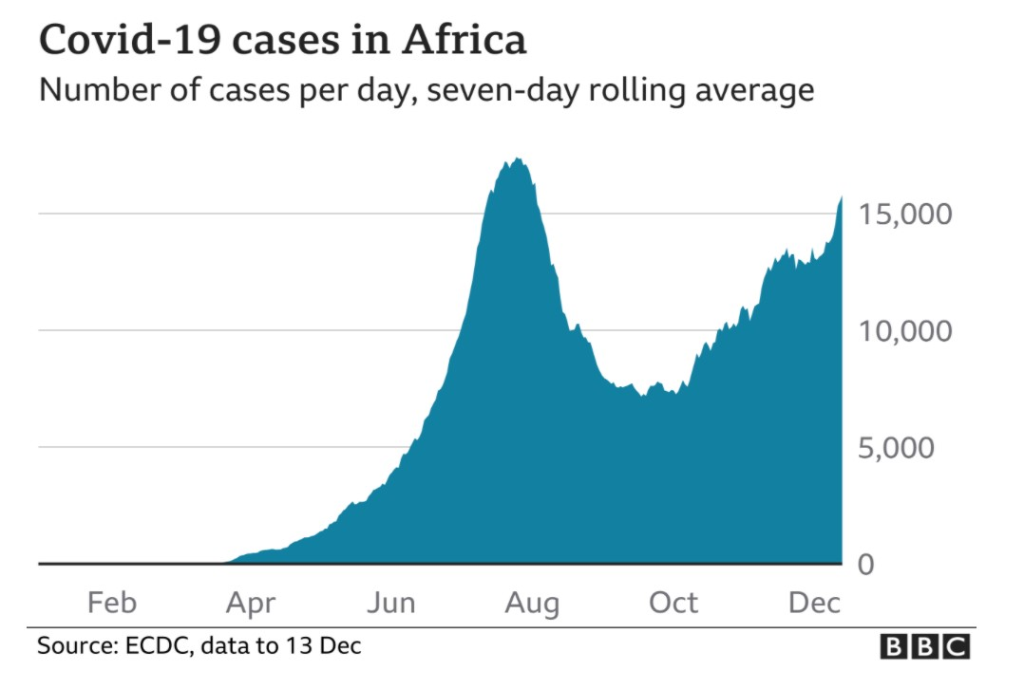

Graph1: Shows the cases in Africa

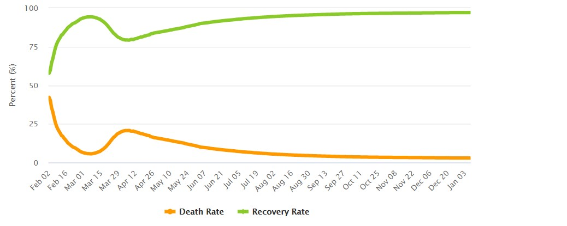

Graph2:Shows the recovery rate and death rate in the whole world



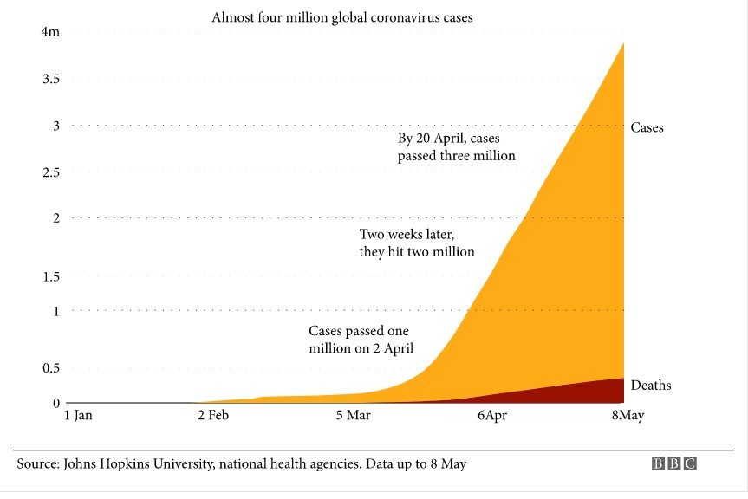

Figure3: shows the change in number of cases and deaths

Tables:

Shows the percentage of symptoms of patient what they feel during covid19

Country

Deaths

Death rate

Total of cases

South Africa 31,809 55.0 1,170,590

Egypt 8,029 8.2 146,809

Morocco 7,645 21.2 448,678

Tunisia 5,052 43.7 152,254

Algeria 2,792 6.6 101,382

Ethiopia 1,966 1.8 127,227

Kenya 1,702 3.3 97,733

Libya 1,558 23.3 103,515

Sudan 1,468 3.5 23,316

Equations:

Total cases:

Sudan- Kenya – Algeria -Libya- Ethiopia- Egypt- Tunisia- Morocco -South Africa

23,316- 97,733- 101,515 -103,515 -127,227 -146,809 -152,254 -448,678 -1,170,590

Median:

Ethiopia 127,227

Mode:

No mode

Med-Range : $\frac{Highest+lowest}{2}$

$\frac{H+L}{2}$ = $\frac{1,170,590+23,316}{2}$ =596,953

Range: Highest -Lowest

H-L=1,170,590 - 23,316 = 1,147,274

Some Statistics equation:

The quartiles:

Q₁= $\frac{97,733+101,515}{2}$ = 99,624

Q₂=127,227

Q₃= $\frac{152,254+448,678}{2}$ = 300,466

The outlier:

IQR=Q₃-Q₁

=300,466-99,624

=200,842

Outlier1= Q₁-1.5(IQR)

=99,624-1.5(200,842)

=-201,639(No outlier)

Outlier2=Q₃+1.5(IQR)

=300,466+1.5(200,842)

=601,729

The outlier is 1,170,590

**Section3:Methodology**

Study design and settings:

Coronavirus disease (COVID19) was first reported in China in December 2019, and has spread

rapidly to the rest of the world. COVID-19 has recently been declared a pandemic by the World

Health Organization (WHO), with more than 180,000 recorded cases to date. COVID-19 is a new corona virus that is likely to have originatedfrom an animal source and is now

quickly spreading from person to person. Typical COVID-19 symptoms can range

from mild to severe respiratory disease. The most common symptoms that have been shown are so far, fever, coughing, and shortness of breath have been registered. The elderly population is more likely to develop serious illnesses, especially those with underlying medical conditions

such as chronic bronchitis, emphysema, heart disease, or diabetes.so we decided to talk about covid19. We collected data via Microsoft form

Participants:

We did a survey about covid-19. We collected data from different people from different ages it contains students from different universities. We asked them to fill the survey and use the results to support our topic. We gave a 9 questions asking them about their knowledge about covid-19 and its details.

Study tool:

The purpose of our survey is to be sure of the awareness of the people about covid-19. So we asked them questions like “Did you adhere to the quarantine period?” and “Did you Commit the Procedures to stay safe from coronavirus? (As mask, alcohol .... etc)”. we get many responses from people and most of them are Conscious enough

Survey and data analysis:

The Average time to complete the survey was 03:04

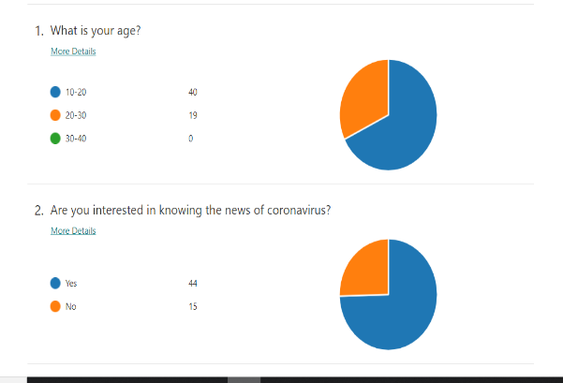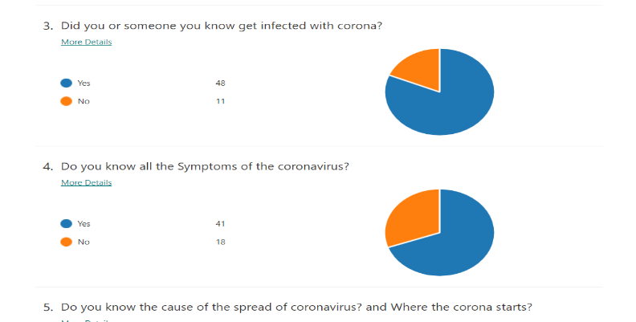

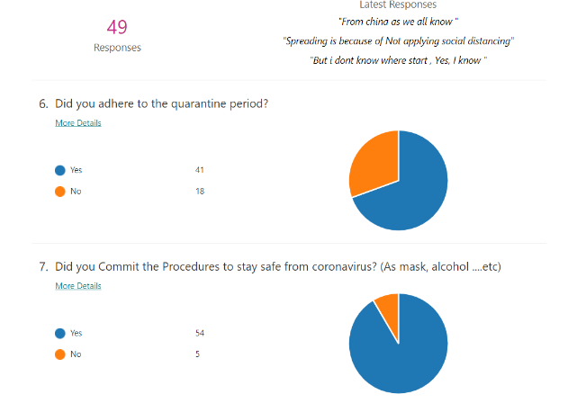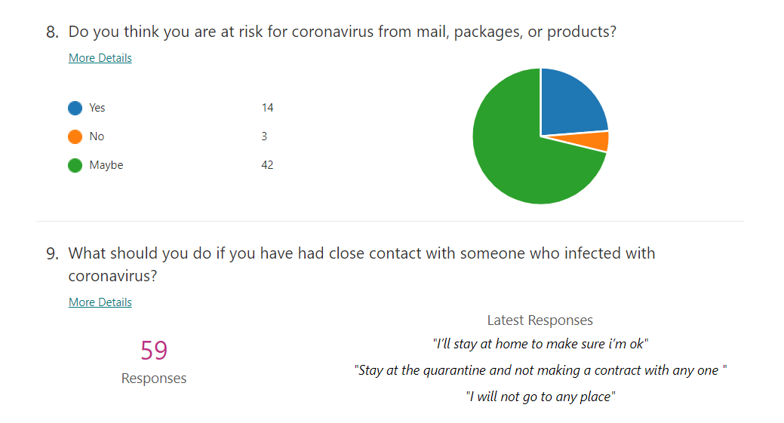

Clinical evidence confirms that COVID 19 transmission occurs from person to person through several different routes: contact with respiratory droplets generated by an infected individual through the breathing, sneezing, or coughing of an infected individual; direct (person-to-person) or indirect (hand-mediated) transfer of the virus from contaminated fomites to the mouth, nose, or eyes. Based on existing literature, the time from exposure to development of symptoms of SARS-CoV-2 ranges typically from 2–14 days13, with a mean of 5.2 days11. Although trace limiting steps act to minimize transmission by reducing the total number of contacts (preventing the sharing of the same space by susceptible individuals) social distancing measures such as disinfecting hands, observing physical distance, wearing masks, avoiding contamination by touching surfaces can all be seen as factors that act on decreasing the probability of disease transmission when a susceptible person and a carrier do share the same location. In terms of viral load profile, SARS-CoV-2 peaks at around the time of symptom, suggesting that the peak of the transmission may occur at an early stage of infection12, likely even a few days prior to any detectable symptoms. To capture these patterns in the transmission timeline, we further partition the traditional Exposed compartment, to differentiate between latent individuals L(t) (who have been exposed to the virus, but are still in the latent, relatively noninfectious stage), and PR symptomatic individuals P(t) (who entered the high transmission stage, but are not yet symptomatic). A review study that used age-specific case data from 32 settings in six countries quantified the differences in infection rates and symptom severity across ages. We used this study to inform our model when choosing the asymptomatic proportions in each age compartment.

We analyzed a COVID-19 dataset representing the reported virus-positive cases in the World as of July 24, 2020, obtained from <https://covid.ourworldindata.org/data> . We extracted the COVID-19 cases reported in 51 African countries and plotted these individually to show the trajectory of the COVID-19 pandemic for each country. Next, we aggregated all the reported COVID-19 cases in Africa since March 1, 2020. Then we used the Susceptible-Infected-Removed (SIR) mathematical model [15,16] to predict the temporal dynamics of the COVID-19 spread, the expected number of infection cases, and the duration of the pandemic in Africa. Briefly, the principal assumption of the SIR model is that the population, in which the viruses (or other pathogens) spreads is comprised of three subgroups of individuals. Those uninfected and susceptible (S) to infection, 2) those infected (I) and can transmit the infection to the uninfected, 3) and those individuals removed (R) from the infection cycle, either because they recovered from the disease and are immune or succumbed to the disease. Improving on the basic SEIR model. One of the most traditional and relatively simple mathematical frameworks to study epidemics at the population level is the Susceptible. This model has already been used in its original form for an early assessment of the epidemic in Wuhan, China. Here, we applied the SIR model implemented in MATLAB and arachnoid.com that we have deposited here to solve the differential equation to model the evolution of a pandemic such as the Coronavirus. <https://arachnoid.com/coronavirus_equation/index.html> .

**In this site we use The Pandemic Explorer by a**djusting the controls to change simulation values:

By using the SIR model to solve the differential equation that can be employed to model infections in populations. It processes these parameters:

* S, the susceptible population, those who are not yet infected.
* I, the infectious population, those who are infected and able to infect others.
* R, the recovered/removed population, those who have already been infected, are no longer infectious, and have either recovered or died.
* $R_{0}$, the rate at which infectious individuals infect others over time.
* $R_{1}$, the rate at which infected individuals remove themselves over time, either by recovering or dying.
* t, time, the system's independent variable.

The equation's terms are:

$\frac{dS}{dt}$ = -SI $R_{0}$ >> (1)

$\frac{dI}{dt}$ = SI $R_{0}$ − $R_{1}$ I >> (2)

$\frac{dR}{dt}$ = $R_{1}$ I >> (3)

Because this equation must be processed numerically, it's necessary to evaluate an outcome for a particular time by computing intermediate results on the interval between time zero and the time of interest. In preparation for this numerical evaluation, the system's dependent variables are assigned these values at time zero:

* S, susceptible, set to 1 ("normalized") in this model (reason given below).
* I infectious, set to 0.01. This is patient zero.
* R recovered/removed, set to 0.
* $R_{0}$, time rate of infection, a user-selected value in the range [0...10].
* $R_{1}$, time rate of recovery/removal, a user-selected value in the range [0...1].

For simplicity and ease of application I use a normalized version of this equation, one in which:

S(t)+I(t)+R(t)=1 >> (4)

and:

+ + = 0 >> (5)

Because this system is normalized, one acquires a specific forecast by multiplying its results by the population size.

The meaning of equation (4) above is that a population is the sum of S, I, and R, meaning all population members are accounted for and belong to one of the three groups. It also implies that the only way to eliminate infection is to set $R_{0}$ to zero. Without this condition and with sufficient time, everyone will become infected and transition to the recovered/removed (R) group.

Furthermore, we used the SIR model to predict the spread of COVID-19, the expected number of infection cases, and the duration of the pandemic for each country in Africa. Briefly, we obtained the predicted number of COVID-19 using the SIR model. These predictions include multiple data points per day. Therefore, we aggregated the predictions made at irregular time intervals per day to yield a single prediction for each country per day by interpolation using the Cubic spline algorithm. Also, to predict the number of cases of COVID-19 infection of each country, we aggregated the predictions for each month (see figure 6a).

Code description

In python code project:

We make python code for COVID-19 with GUI. First, We start our project with doing **statistics** about Corona based on World Health Organization website first it gives me time and date then Total cases, Total deaths, Total recovered, first the user starts the application and know the last updated version about Corona virus cases. Then, the user was asked many questions as his/her name, age, about symptoms he/she have then after he answer these questions there is a calculation that tells the user the percentage of his infection and based on his age, symptoms he have he knows **the Probability** of his /her fatality rate of dying from COVID-19. Then the program prints some advices for the user to avoid Corona virus.

**flowchart:**

If user have any of these symptomes

Input age, gender

YES

NO

Print the rate of infection of the user from Corona

Read The World Health Statics Organization on Corona virus

Read the advice to avoid Corona

**SECTION 4: RESULTS**

Figures 1 and 2 illustrate the long-term dynamics of the system constructed in “Methods” section, in absence of any isolation, quarantine or closure measures. Figure 1 illustrates the interplay between model compartments (shown in different colors) for each of the four age groups. Figure 2 illustrates a comparison between age groups (shown in different line styles) in each of the seven compartments (shown in separate panels). There is a period of seemingly exponential growth in infections, followed by a peak at around 100 days, and a decline, with the number of fatalities monotonically increasing towards a different asymptotic value for each group (largest in the elderly, smaller in adults, etc.). In further illustrations, we will focus in particular on the number of infected cases (relevant to the current stage of the epidemic, and to the strain on the health care system), on recovered individuals (who may be subject to lifelong consequences, whether they had been symptomatic of not). The first response strategies applied in response to the COVID 19 epidemic were focused primarily on mandated closures (i.e., mobility restrictions) rather than on social distance requirements (e.g., the recommendations on wearing masks were rather mixed over the first few weeks of the outbreak).

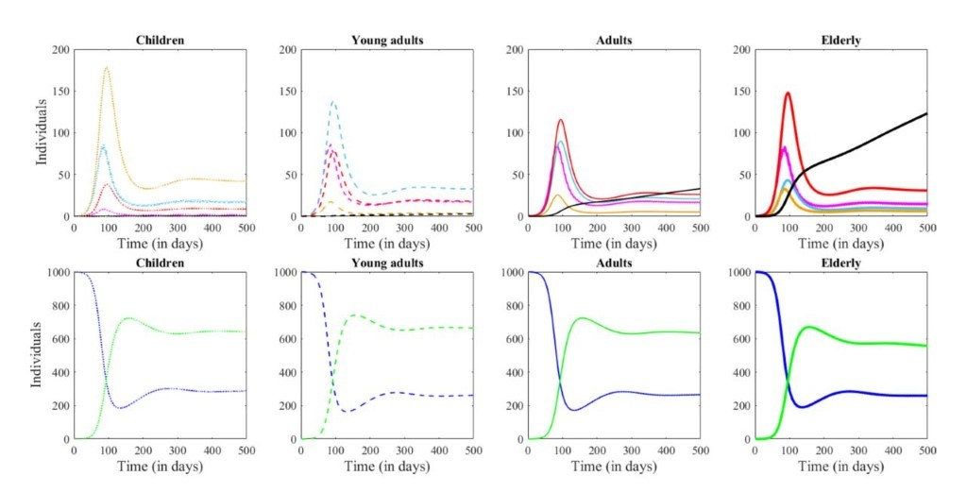Figure 1. System dynamics in absence of any preventive measures. Each column shows the evolution of one age group (from left to right: Children, Young adults, Adults and Elderly). The Symptomatic and Recovered compartments are shown in separate panels, for clarity of the illustration (larger scale than the other compartments). The number of Susceptible individuals is shown in blue, the Latent in pink, Asymptomatic in cyan, PR symptomatic in orange, infected in red, the Recovered in green and the Fatalities in black.

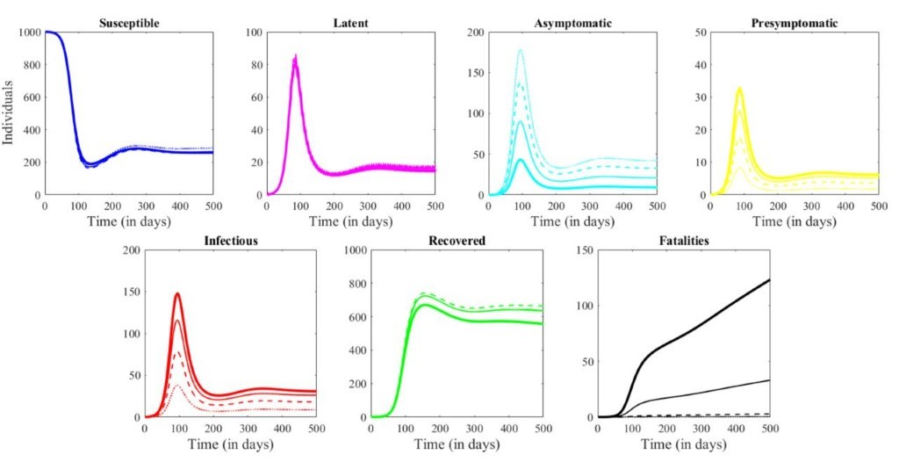Figure 2. System dynamics in absence of any preventive measures. Each panel shows the dynamics in one model compartment (from left to right: Susceptible, Exposed, Infected, Recovered and Dead.) In each panel, each age is represented by a different line type: Children as a dotted line, Young adults are a dashed line, Adults as a thin solid line and Elderly as a thick solid line.

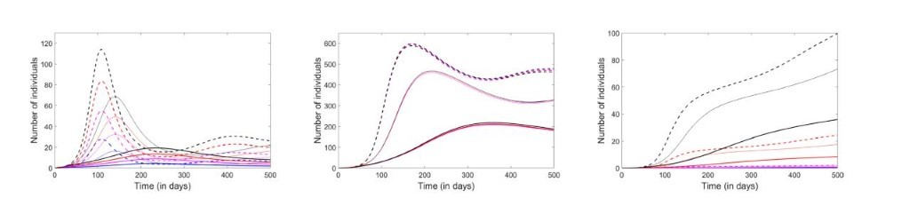Figure 3. Effect of exercising social distancing in addition to the existing shutdowns. The left panel represents the infected compartment, the center panel the recovered, and the right panel, the fatalities. Each age group is represented in one color: Children (blue), Young adults (pink), Adults (red) and Elderly (black). The dashed curves illustrate the original predictions; the thin solid curves represent the evolution of the system when the value of the exposure parameters was decreased by 20% of the original values, to reflect the effect of social distancing at all destinations; the thick solid curves represent a deeper, 40% reduction of β values.

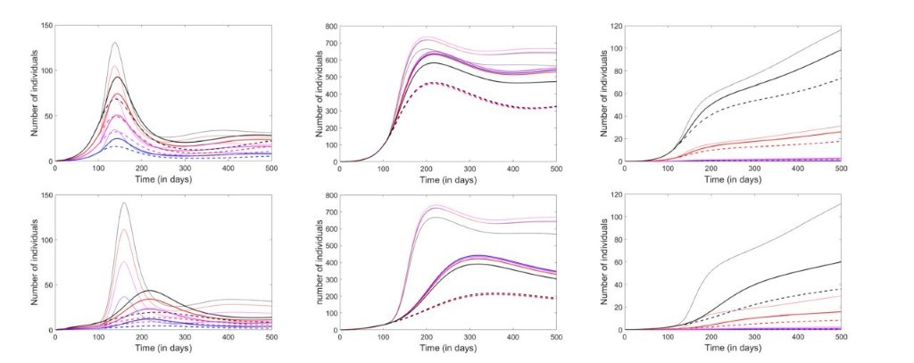Figure 3. Effect of lifting closures and relaxing social distancing after 100 days. From left to right, the panels represent the infected, the recovered and the fatalities compartments. Each age group is represented in one color: Children (blue), Young adults (pink), Adults (red) and Elderly (black). The dashed curves illustrate the prediction with closures and social distancing in place. The thin curves illustrate the prediction with both closures and social distance restrictions lifted. The thick curves represent a scenario in which closures are lifted, but social distancing is maintained. In the top panels, β is reduced by 20% with social distancing; in the bottom panels, it is reduced by 40%.

We also provided valuable intuition regarding the expected trajectory of the disease in Africa.

**COVID-19 in Africa** We obtained a dataset of the global COVID-19 cases from covid.ourworldindata.org. We found that out, as of July 24, 2020, 45 out of 56 African counties have reported the number of COVID-19 positive cases. We extracted information on COVID-19 cases in African countries and make a visualization for Africa to show that South Africa has reported the highest number of cases (408,052), followed by Egypt (90,413) and Nigeria (38,948; Figure 4).

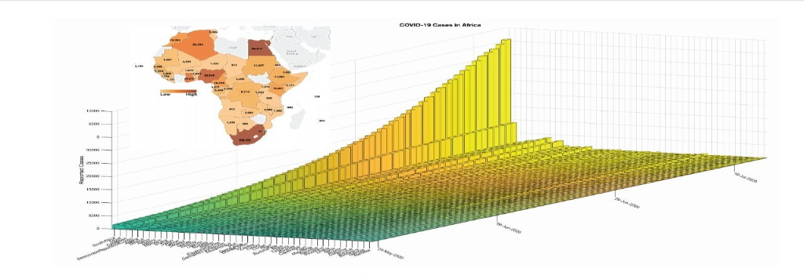Figure 4: Status of the COVID-19 pandemic in Africa as of 28th May 2020.

We obtained the daily COVID-19 cases in Africa starting March 1, 2020, by aggregating all the reported cases per day for each country in Africa. Then, we utilized the susceptible-infected-removed (SIR) epidemic model to estimate the trajectory of the pandemic in Africa. Here, our model has accurately predicted the cases of COVID-19 in Africa with statistical significance (R2 = 0.999, p-value = 1.3 x 10-253; Figure 5). Furthermore, our results showed that, in Africa, the COVID-19 pandemic would be at the turning point on August 8 2020, get to the steady growth phase around October 2 2020, and the ending phase will begin around November 24 2020. Overall, based on the current data and the trajectory of COVID-19 positive cases, we predict that COVID-19 will infect another 1,451,567 individuals to bring the total number of COVID-19 positive cases to about 2,201,849.

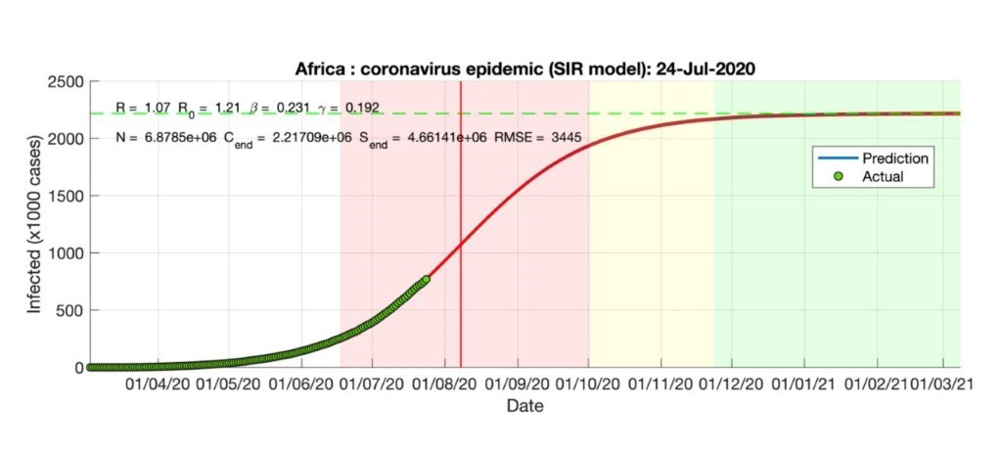

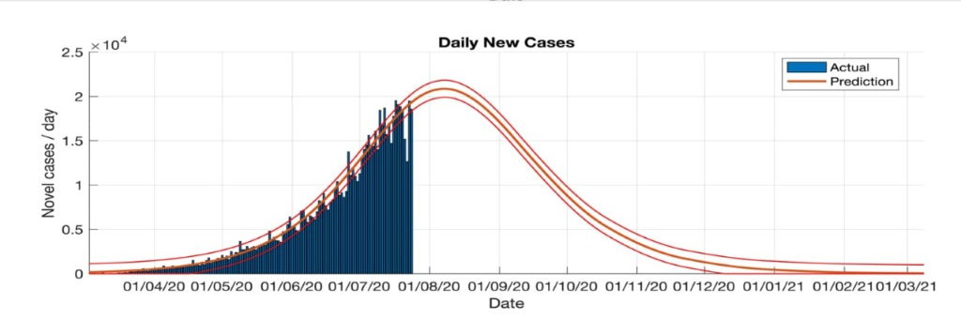Figure 5: Predicted and actual cases of COVID-19 based on the SIR model as of 28 May 2020.

Next, we used the SIR model to predict the spread of COVID-19, the expected total number infected, and the duration of an epidemic in each African Country. Here, our results showed that, for most countries in Africa, we would expect to see fewer monthly COVID-19 cases.

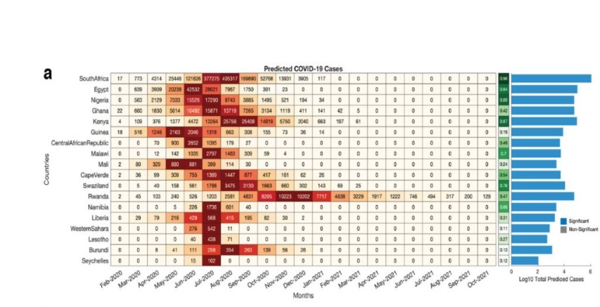Figure 6: (a) Left; heatmap showing the predicted COVID-19 cases per month based on the SIR model for each country in Africa. Middle; Pearson’s linear correlation (R-square) between the predicted and actual daily COVID19 across each country. The bar graphs represent the based ten logarithms transformed total numbers of predicted COVID-19 cases from the start to the end of the COVID-19 pandemic. Note: the strength of the predictions made for each country should be evaluated based on the given R-square values. Other African countries are not shown in the heatmap because our SIR-model had failed to make statistically significant predictions. The bars are colored based on the false discovery rate p-values of the SIR model of each country; blue denotes q-values < 0.05 and grey denotes q-values > 0.05. Predicted and actual cases of COVID-19 based on the SIR model.

COVID-19 in most affected African countries versus the rest of the World We compared the reported COVID-19 positive cases in the most impacted countries in Africa (South Africa and Egypt) to those in other countries that have been affected across the globe. Here, we showed that the scale of the COVID-19 cases has steadily increased, with the scale of the pandemic in South Africa supposing that in Japan, China, Italy, and United Kingdom (Figure 7a). This assertion remains valid even when we consider the number of reported COVID-19 cases as a percent for each of the country's population size (Figure 7b).

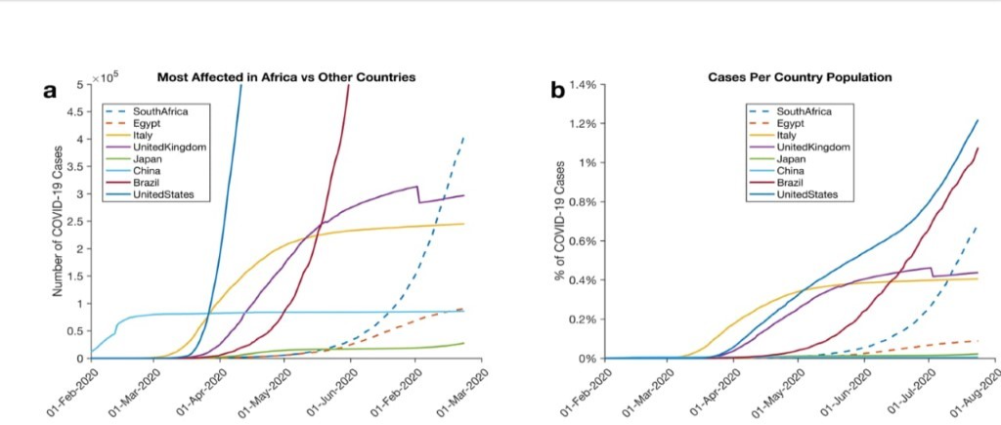Figure 7: Comparison of COVID-19 Cases reported in some of the most affected countries in Africa (South Africa and Egypt) and countries on other continents. (a) Lines show the total number of reported COVID-19 cases. (b) Lines show the percentage of COVID-19 infected individuals for each country.

In python code with GUI for COIVD-19:

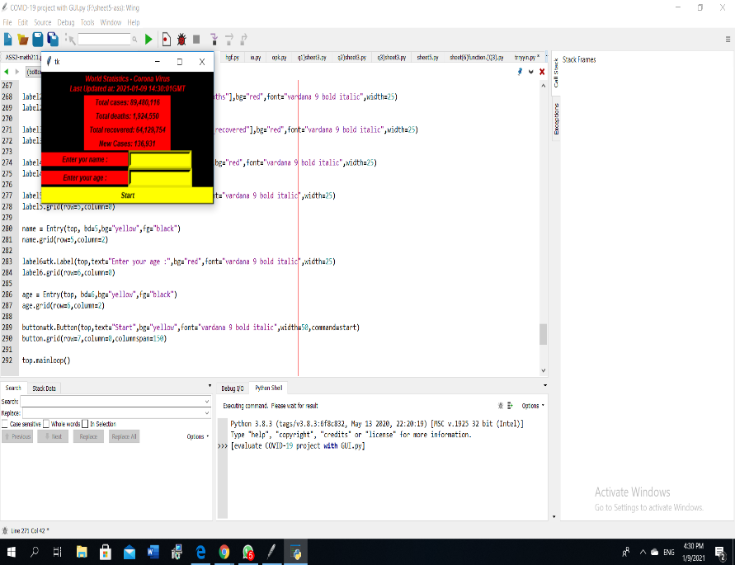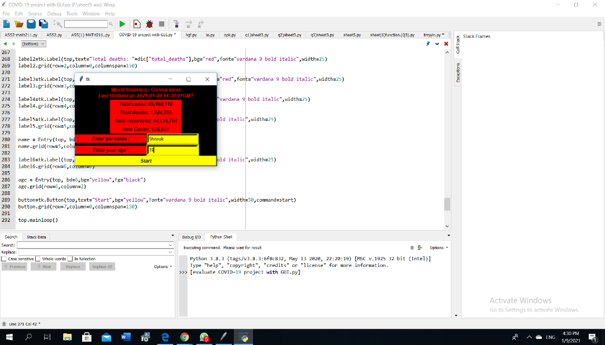

In (figure 1), the user knows **some statistics** about COVID-19 based on World Health Organization website as it gives the user time and date then Total cases, Total deaths, Total recovered, then the user was asked to enter his/her name and age.

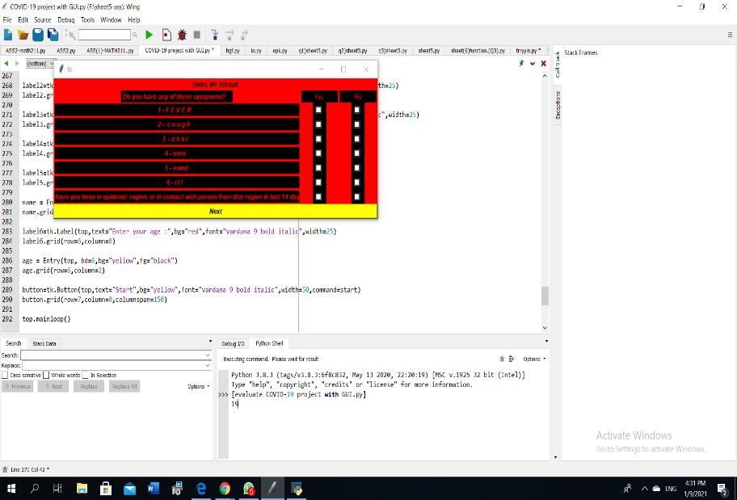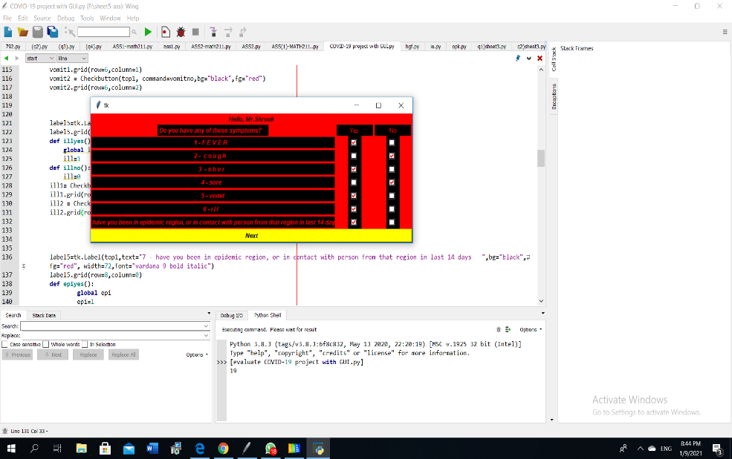

In (figure 2), the user was asked many questions about the symptoms he have like (cough, shor, fever, sore, vomit, have you been in epidemic region, or in contact with person from that region in last 14 days).

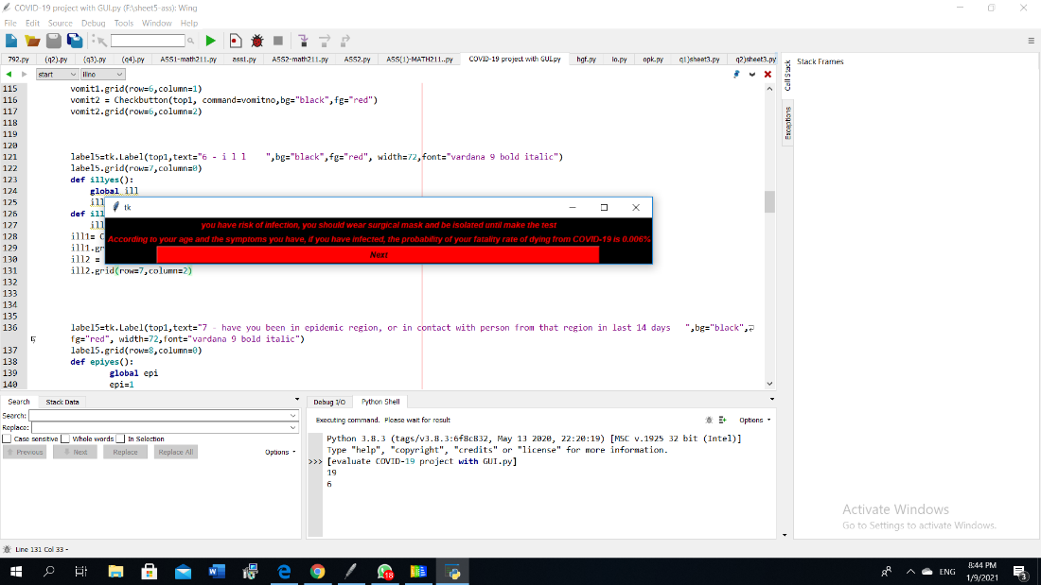

In (figure 3), after he answer these questions there is a calculation that tells the user the percentage of his infection and based on his age, symptoms he entered he knows the ***Probability*** of his /her fatality rate of dying from COVID-19.

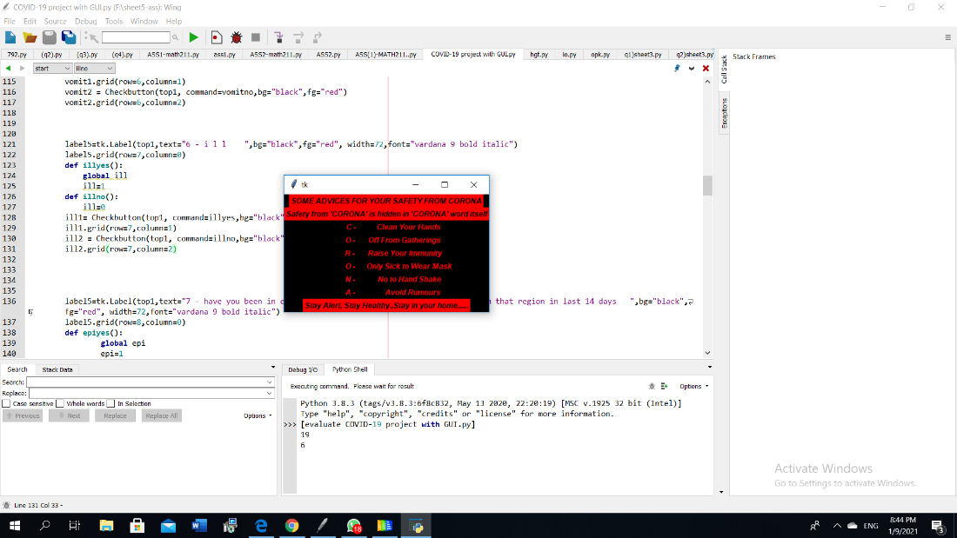

In (figure 4), the program prints some advices for the user to avoid Corona virus

**Discussion**

First, we constructed a visualization show the dynamics in case of absence of any isolation, quarantine or closure measures, then we compare between age groups. After that, we talked about the effect of exercising social distancing in addition to the existing shutdowns, and the effect of lifting closures and relaxing social distancing after 100 days.

Secondly, we conducted a predictive analysis of the COVID-19 pandemic in Africa. Our results show that the scale of the pandemic is low across many countries in Africa. Many experts have debated the reason why fewer cases of COVID-19 are being reported in Africa. Some have pointed toward the lack of widespread testing of COVID-19, whereas others point towards the African climate. We showed that, on average, most counties in Africa, including Zimbabwe, Malawi, and Benin, have reported fewer than 10,000 COVID-19 cases. Conversely, most European countries have reported, on average more than 30,000 COVID-19 cases. Importantly, in most of the counties on the continent, our prediction shows that the number of COVID-19 cases reported in July 2020 are unlikely to be surpassed by those in the next few months. Furthermore, we predicted that COVID-19 pandemic would disproportionately affect different countries in Africa. We expect that even the worst affected among these would report COVID-19 positive cases that are comparable to those other regions of the World. Interestingly, our model predictions were statistically significantly valid for only 18 of the 51 individual African countries for which we predicted the spread of the COVID19 pandemics. Therefore, we encourage everyone (including individuals in African countries) to adhere to the guidelines that are aimed at reducing the spread of the COVID-19 virus.

# **SECTION 5: CONCLUSION**

In this paper, after we introduced COVID-19 we show the dynamics of COVID-19 by making a survey and show the methods with taking into consideration the S-I-R Model. In addition, using MATLAB, and arachnoid to solve the differential equations of the pandemic and make a visualization of the affected ages, system dynamics in absence of any preventive measures, effect of exercising social distancing in addition to the existing shutdowns, and the effect of lifting closures and relaxing social distancing after 100 days. In addition, we provided valuable intuition regarding the expected trajectory of the disease in Africa.COVID-19 in Africa We obtained a dataset of the global COVID-19 cases. We extracted information on COVID-19 cases in African countries and make a visualization for Africa. Our results show that the scale of the pandemic is low across many countries in Africa. Also, with the virus spreading easily from person-to-person in many parts of that country. the world is working to contain the spread of the virus through public health measures such as social distancing, contact tracing, testing, quarantines and travel restrictions. Scientists are working to find medications to treat the disease and to develop treatments and vaccines are developed to stop it.

# **REFERENCES**

[1] Roda WC, Varughese MB, Han D, Li MY. Why is it difficult to accurately predict the COVID-19 epidemic? Infect Dis Model 2020; 5:271–81. doi: 10.1016/Jim.2020.03.001.

[2] Zu ZY, Jiang M Di, Xu PP, Chen W, Ni QQ, Lu GM, et al. Coronavirus Disease 2019 (COVID-19): A Perspective from China. Radiology 2020:200490. doi:10.1148/radiol.2020200490.

[3] Batista M. Estimation of the final size of the coronavirus epidemic by the logistic model. MedRxiv 2020:2020.02.16.20023606. doi:10.1101/2020.02.16.20023606.

[4] Coronavirus Update (Live): 6,150,262 Cases and 370,500 Deaths from COVID-19 Virus Pandemic - Worldometer n.d. https://www.worldometers.info/coronavirus/ (accessed May 31, 2020).

[5] The Lancet. COVID-19: protecting health-care workers. Lancet 2020;395:922.doi:10.1016/S0140-6736(20)30644-9.

[6] Munjita SM, Samutela M, Ndashe K, Munsaka SM. Immunity, parasites, genetics and sex hormones: contributors to mild inflammatory responses in COVID-19? PAMJ 2020. doi:10.11604/PAMJ.SUPP.2020.35.2.23267.

[7] Peng L, Yang W, Zhang D, Zhuge C, Hong L. Epidemic analysis of COVID-19 in China by dynamical modeling. n.d.

[8] Calafiore GC, Novara C, Possieri C. A Modified SIR Model for the COVID-19 Contagion in Italy. 2020.

[9] Danon L, Brooks-Pollock E, Bailey M, Keeling MJ. A spatial model of CoVID19 transmission in England and Wales: early spread and peak timing. MedRxiv 2020:2020.02.12.20022566. doi:10.1101/2020.02.12.20022566.

[10] Jewell NP, Lewnard JA, Jewell BL. Predictive Mathematical Models of the COVID-19 Pandemic: Underlying Principles and Value of Projections. JAMA - J Am Med Assoc 2020;323:1893–4. doi:10.1001/jama.2020.6585.

[11] Enserink M, Kupferschmidt K. With COVID-19, modeling takes on life and death importance. Science (80- ) 2020;367:1414–5. doi:10.1126/science.367.6485.1414-b.

[12] Wu K, Darcet D, Wang Q, Sornette D. Generalized logistic growth modeling of the COVID-19 outbreak in 29 provinces in China and in the rest of the World 2020.

[13] Batista M. Estimation of the final size of the second phase of the coronavirus COVID 19 epidemic by the logistic model 2020. doi:10.1101/2020.03.11.20024901.

[14] Batista M. (PDF) Estimation of the final size of the coronavirus epidemic by the SIR model. Estim Final Size Coronavirus Epidemic by SIR Model 2020. https://www.researchgate.net/publication/339311383_Estimation_of_the_final_ size_of_the_coronavirus_epidemic_by_the_SIR_model (accessed May 29, 2020).

[15] Hethcote HW. The Mathematics of Infectious Diseases. vol. 42. 2000.

[16] Jones JH. Notes On R 0 1 The Basic Reproduction Number in a Nutshell. 2007.

[17] Agyeman AA, Laar A, Ofori-Asenso R. Will COVID-19 be a litmus test for postEbola sub-Saharan Africa? J Med Virol 2020. doi:10.1002/jmv.25780.

[18] Kobia F, Gitaka J. COVID-19: Are Africa’s diagnostic challenges blunting response effectiveness? AAS Open Res 2020;3:4. doi:10.12688/aasopenres.13061.1.

[19] Kavanagh MM, Erondu NA, Tomori O, Dzau VJ, Okiro EA, Maleche A, et al.

[20]. World Health Organization. Transmission of SARS-CoV-2: implications for infection prevention precautions. https://www.who. int/news-room/commentaries/detail/transmission-of-sars-cov-2-implications-for-infection-prevention-precautions. Accessed 08 April 2020.

[21]. Koh, W. C., Naing, L., Rosledzana, M. A., Alikhan, M. F., Chaw, L., Grifth, M., Pastore, R. & Wong, J. What do we know about sars-cov-2 transmission? a systematic review and meta-analysis of the secondary attack rate, serial interval, and asymptomatic infection. medRxiv (2020).

[22] Sajadi MM, Habibzadeh P, Vintzileos A, Shokouhi S, Miralles-Wilhelm F, Amoroso A. Temperature and Latitude Analysis to Predict Potential Spread and Seasonality for COVID-19. SSRN Electron J 2020. doi:10.2139/ssrn.3550308.

[23] McCluskey CC. Complete global stability for an SIR epidemic model with delay - Distributed or discrete. Nonlinear Anal Real World Appl 2010;11:55–9. doi:10.1016/j.nonrwa.2008.10.014.

[24] Satsuma J, Willox R, Ramani A, Grammaticos B, Carstea AS. Extending the SIR epidemic model. Phys A Stat Mech Its Appl 2004;336:369–75. doi:10.1016/j.physa.2003.12.035.

[25] Batista M. fitVirusCOVID19 - File Exchange - MATLAB Central. FitVirusCOVID19 2020. https://uk.mathworks.com/matlabcentral/fileexchange/74658-fitviruscovid19 (accessed May 29, 2020).

[26] De Boor CR. A Practical Guide to Spline 2014. doi:10.2307/2006241.

[27] Akima H. A New Method of Interpolation and Smooth Curve Fitting Based on Local Procedures. J ACM 1970;17:589–602. doi:10.1145/321607.321609.